**Sprint 2 Plan**

**Product name:** Peergrader

**Team name**: Peergrader

**Sprint completion date:** May 7, 2024

**Revision number:** 1

**Revision date:** Apr 28, 2024

**Goal:**

Maximum total hours/story points per Sprint: 60

**User Stories:**

1. User Story 2.1 [10 story points] As a student I want to be able to go to an assignment and turn in a file.
2. User Story 2.2 [20 story points] As a student I want to be able to see the number of people I need to grade, be able to see their submissions, and give them a grade based on the rubric for that assignment.
3. User Story 2.3 [15 story points] As an instructor I want to be able to customize the score based on grading, grading score, and score on rubric. And customize assignment deadlines - submission and grading.
4. User Story 2.4 [20 story points] As a student I want to be able to comment on the pdf when grading other students to provide specific feedback.

**Tasks Listing:**

User Story 2.1

* Create an assignment page
* Create a submissions table to link the files with assignment
* Make attractive and intuitive UI

User Story 2.2

* Create a grading page that shows me the pdfs of students I need to grade
* View the rubric on the grading page and make a selection of the rubric
* Show the number of students needed to grade and graded
* Make attractive and intuitive UI

User Story 2.3

* Allow the rubric to be editable (add rows and columns).
* Assign a total score points for each assignment and row
* Set a deadline date on assignment creation
* Show the deadlines in student view
* Make attractive and intuitive UI

User Story 2.4

* Make a tag associated with comments
* Create a text field comment block associated with the rubric.
* Store the coordinates of the comment tag with file id and comment
* Make attractive and intuitive UI

**Infrastructure:**

* Postgresql database: Supabase
* Storage (files): Supabase
* Deployment: Vercel
* GitHub: Version control
* Framework: next.js

**Team roles:**

* Christian Knab: Team member
* Aastha Verma: Team member
* Eliah Reeves: Product owner
* Eric Chuang: SCRUM Master

**Initial task assignment:**

* Aastha Verma: User Story 2.1-2.4 UI for course page
* Eliah Reeves: User Story 2.4 Create comment tags and pdf viewer
* Christian Knab: User Story 2.3 Make rubric editable and upload to supabase
* Eric Chuang: User Story 2.2 Give student a number grade

**Burnup Chart:**

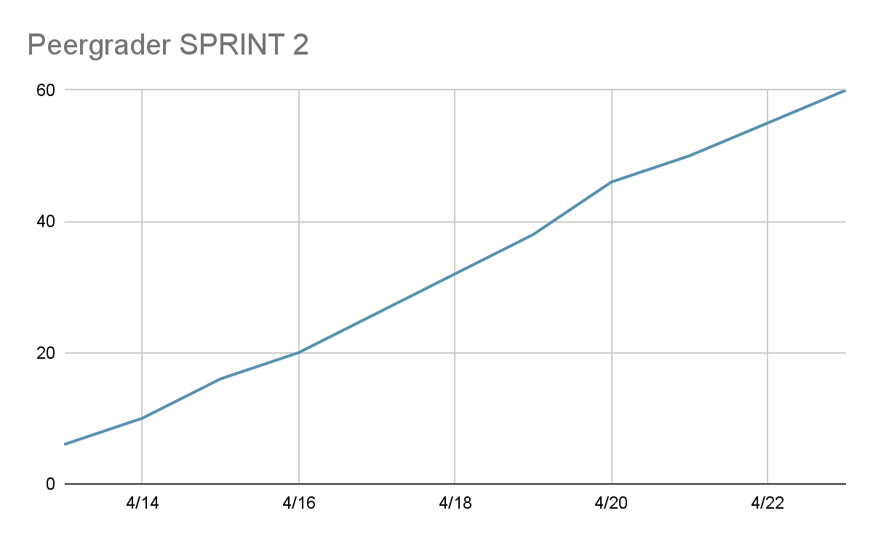

**SCRUM board**

| **User Story** | **Not Starter** | **In Progress** | **Done** |
| --- | --- | --- | --- |
| As a student I want to be able to go to an assignment and turn in a file. |  | Make attractive and intuitive UI | Create an assignment page  Create a submissions table to link the files with assignment |
| As a student I want to be able to see the number of people I need to grade, be able to see their submissions, and give them a grade based on the rubric for that assignment. | Show the number of students needed to grade and graded | Create a grading page that shows me the pdfs of students I need to grade  Make attractive and intuitive UI | View the rubric on the grading page and make a selection |
| As an instructor I want to be able to customize the score based on grading, grading score, and score on rubric. And customize assignment deadlines - submission and grading. | Show the deadlines in student view | Set a deadline date on assignment creation | Allow the rubric to be editable (add rows and columns).  Assign a total score points for each assignment and row |
| As a student I want to be able to comment on the pdf when grading other students to provide specific feedback. | I | Make a tag associated with comments  Create a text field comment block associated with the rubric.  Store the coordinates of the comment tag with file id and comment  Make attractive and intuitive U |  |

**Schedule of Scrum meetings**

* When: Mon/Wed/Fri 9am-11am
* Where: Jack’s Lounge Baskin Engineering
* TA meeting: Monday 11-12pm ZOOM